Registry of Chronic Pancreatitis
User’s Guide

Contents
Prologue 2
Online interface: 3
1. Personal details (first section): 4
2. Details of the diagnoses (second section): 5
3. Details from medical history (third section): 6
4. Etiology (fourth section): 6
5. Complains, symptoms (fifth section): 7
6. Admission details and state (sixth section): 7
7. Laboratory parameters on admission (seventh section): 8
8. Imaging examinations on admission (eight esction): 8
9. Functional examinations (ninth section): 11
10. Hystology: 11
11. Genetic testing: 11
12. Conservative therapy: 11
13. Intervention treatment: 11
14. Complications: 12
15. Epicrisis: 13
16. Ambulant page and final report: 14
17. Complete uploading. 14

Prologue
The Registry of Pancreas two main aims:
- detailed summary of patients, specific diseases, prospective clinical research data, performance of statistic analysis
- storage of patient’s biological (blood or tissue) sample, genetic studies and another examination from patient’s samples

Uploading ways:
- online form for direct data upload
- printed form from: http://opr2.pancreas.hu/en

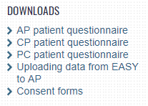

Data security
During upload, increased attention should be given to the security of personal data, with special regards to the covering and deletion of personal data (name, date of birth, social security number, etc.) found in the headers, footers, and other parts of attached documents, diagnostic reports, final reports, radiograms, and other images and documents. The filtering of incidental mistakes stemming from the abovementioned issue is also essential during monitoring (2nd, 3rd, and 4th check-marks).

Online interface:
Log in to http://opr2.pancreas.hu/en and find Registry of Chronic Pancreatitis on the left.
If you click the „KP” icon you can upload new cases to the registry. The icon next to it directs you to previously uploaded patients.

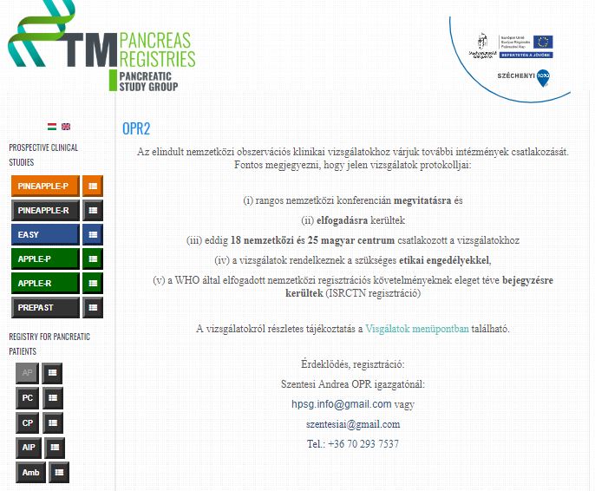

1. Personal details (first section):
You have to fill every field. Please mark ’no data’ if you don’t have the required information.
In this section, you should fill the personal details, date of interview, reason of admission (acut or planned), institute, doctor code, patient’s blood sample code, date of blood sampling.

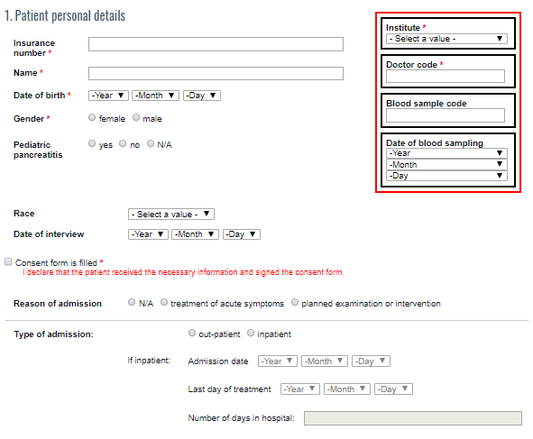

Please make sure to mark that the patient has received the necessary information and signed consent form.

2. Details of the diagnoses (second section):
You have to fill every field. Please mark ’no data’ if you don’t have the required information.
Make sure to upload description of examinations conforming the diagnosis.
If you don’t know the exact date of the diagnosis (only year), please mark 1st of January.
At the diagnostical examinations you have to copy the whole description into the field in English.
In special cases, it is enough to translate lines reffering to pancreas only.
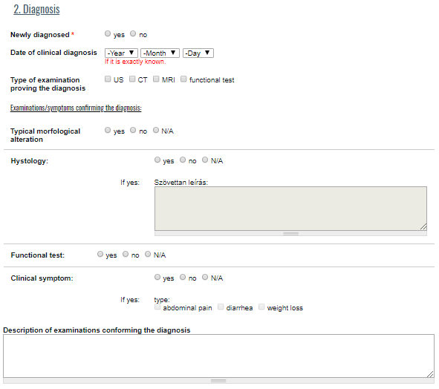

3. Details from medical history (third section):
You have to fill every field. Please mark ’no data’ if you don’t have the required information.
- Smoking
- Alcohol consumption
- Drug abuse
- Diabetes mellitus
- Lipid metabolism disorder
- Any disease of the pancreas
- If the patient had Acute pancreatitis/chronic/autoimmune pancreatitis/pancreatic cancer in the history? (When was it diagnosed? How many times did the patient have acute episodes before this episode?)
- Pancreas disorders in family history
- Congenital Anatomical Malformation of the pancreas
- Other illnesses
- Medications taken regularly
- Diet
- Case history = anamnesis

4. Etiology (fourth section):

You have to fill every field. Please mark ’no data’ if you don’t have the required information.
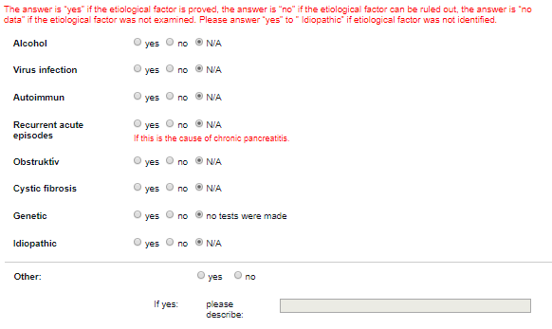

5. Complains, symptoms (fifth section):

You have to fill every field. Please mark ’no data’ if you don’t have the required information.
- Abdominal pain
- Generally abdominal pain
- Nausea/Vomiting
- Subfebrility/fever
- Appetite
- Weight loss
- Stool
- Enzym substitution

6. Admission details and state (sixth section):

You have to fill every field. Please mark ’no data’ if you don’t have the required information.
- Blood pressure
- Heart rate
- Body weight
- Body height
- Respiratory rate
- Body temperature
- Abdominal tenderness
- Abdominal guarding
- Jaundice

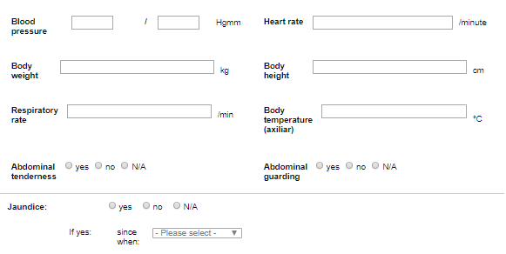

7. Laboratory parameters on admission (seventh section):

Please upload the initial laboratory parameters on admission or the newer evidence with most data.

8. Imaging examinations on admission (eight esction):
You have to fill every field. Please mark ’no data’ if you don’t have the required information.
This section has three parts.
First section:
You need to copy the description of Abdominal Ultrasound, Abdominal X-ray, Chest X-ray, Chest Computed Tomography and/or Abdominal Computed Tomography in the first part.
After this mark the six criteria above this field. (as shown in red)
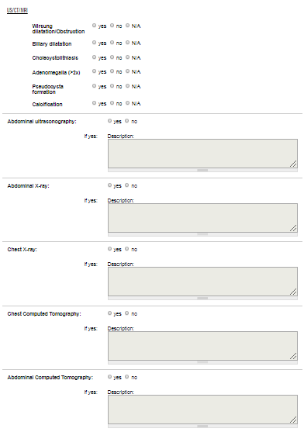

Second section:
You should copy the diagnostical ERCP and/or MRCP in this field.
After this mark the four criteria above this field. (as shown in red)

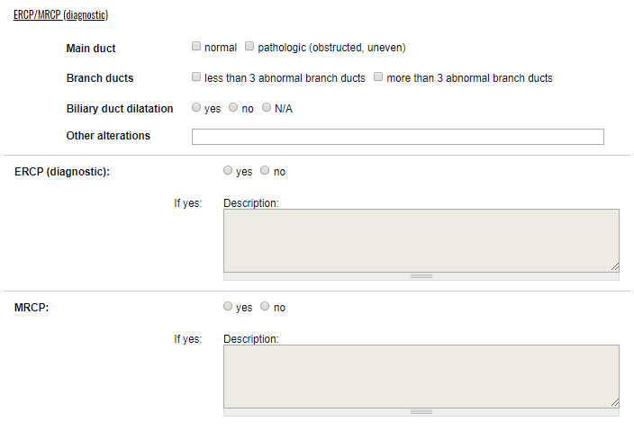

Third section:
Please copy the description of EUS and mark the five criteria above this field.
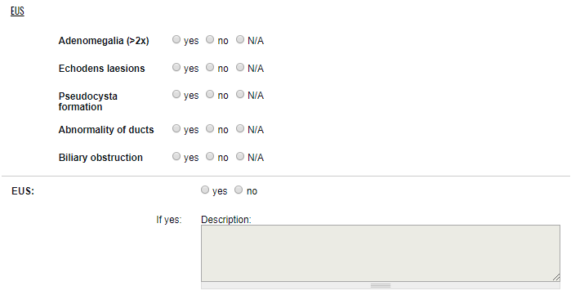

9. Functional examinations (ninth section):
You have to fill every field. Please mark ’no data’ if you don’t have the required information.
- stool - elastase trial
- expiration trail
- another trials

10. Hystology:
You have to fill every field. Please mark ’no data’ if you don’t have the required information.
- Hystology
- Cytology

11. Genetic testing:
You have to fill every field. Please mark ’no data’ if you don’t have the required information.

12. Conservative therapy:
You have to fill every field. Please mark ’no data’ if you don’t have the required information.

Therapy on admission:
- Enzym substitution
- Pain management
- Oral antidiabetics
- Insulin
- Intensive care
- Other

13. Intervention treatment:
You have to fill every field. Please mark ’no data’ if you don’t have the required information.
This section has two parts.
First section:

Endoscopic treatment:
In case of ERCP you need to mark different parameters:
- Successful biliary cannulation
- Precut
- EST
- Stone extraction
- Stent
- Pancreatic duct filling
Please copy the description under the analysis.

Second section:
Surgical treatment:
In case of surgical intervention, you can detail its type and complications. You can also highlight if there was hystology and if reoperation was needed. Please copy the description here as well.

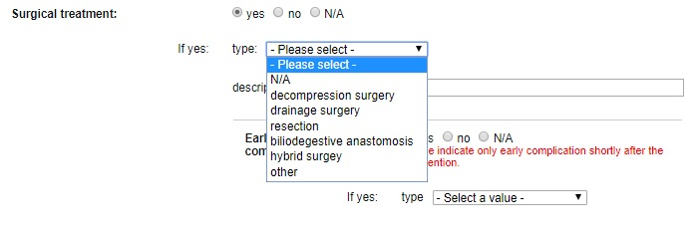

14. Complications:
You have to fill every field. Please mark ’no data’ if you don’t have the required information.
Please register complication(s) related to the disease or the intervention under the hospiatlizaton.
Please mark every developed complications after the diagnosis of chronic pancreatitis.
Pancreatic: only complications developed under the current hospitalization
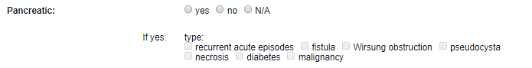
Biliary: biliary occlusion and cholangitis
Organ failure:
- Sepsis
- MOF
- Lung: to be marked, if the patient received oxigen under hospital observation
- Heart: to be marked, if the patient received adrenaline (vasopressore therapy) under hospital observation
- Kidney: to be marked, if the patient’s kreatinin value is higher than 200
Mortality
Other
Description of complications: short summary of the marked complications.
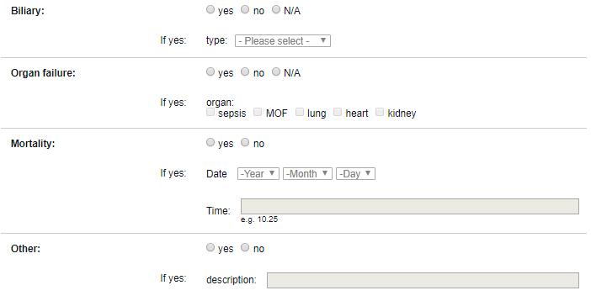

15. Epicrisis:
Obligatory field.
A short summary of the hospitalization (how the patient got to medical care, diagnosis, most important facts and events of the hospitalization, what happened with the patient after the hospitalization, any recommended control examinations, surgery, etc.).

16. Ambulant page and final report:
Please upload the patient’s ambulant page and/or final report without personal details.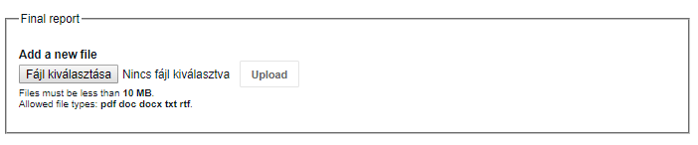

17. Complete uploading.

Finally, you can save your work as draft or finalize it.


