Ultrasonography
Date (dd/mm/yyyy): ………./………./……….

Procedure done by: trainee without supervisor/trainee with/supervisor/senior

Visualization of the pancreas
- Good, complete (head, uncinate proc., body, tail, duct)
- Partially, incomplete (head, uncinate proc., body, tail, duct)
- Poor, non-diagnostic (head, uncinate proc., body, tail, duct)

Homogenity
- Homogeneous
- Inhomogeneous, includes area(s) of low echogenicity
- Inhomogeneous, includes calcifications

Gallbladder inflammation: Yes or No or Uncertain

Gallbladder stone: Yes or No or Uncertain
If Yes, number and size (biggest): ………. ……….mm

Gallbladder polyp: Yes or No or Uncertain
Biggest diameter: ……….mm

Dilated common bile duct: Yes or No or Uncertain
Diameter: ……….mm

Dilated intrahepatic bile ducts: Yes or No or Uncertain

Peripancreatic fluid:. Yes or No or Uncertain

Edematous pancreas: Yes or No or Uncertain

Enlarged pancreas: Yes or No or Uncertain

Atrophic pancreas: Yes or No or Uncertain

Irregular pancreas contours: Yes or No or Uncertain

Blurred pancreas contours: Yes or No or Uncertain

Acute pancreatitis: Yes or No or Uncertain

Chronic pancreatitis: Yes or No or Uncertain

Dilated pancreatic duct (PD): Yes or No or Uncertain
Diameter (head-body-tail): ……….-……….-………. mm
If dilated: Diffuse Segmental (head body tail)

Pancreatic duct stone: Yes or No or Uncertain
Size: ……..mm Number: ………..

Pancreatic cystic neoplasms: Yes or No or Uncertain
Cyst Number: ……….
Unifocal or Multifocal
Size (biggest): ………. mm
Location of dominant cyst: HoP or BoP or ToP
Multilobularity: Yes or No or Uncertain
Number of lobules: ……….
Type of multilobularity
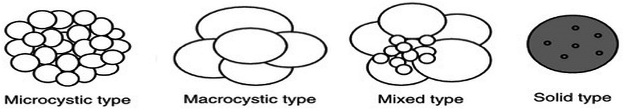
Microcystic Macrocystic Mixed Solid
Septums: Yes or No or Uncertain
Thickened septation or Thin septation
Solid component/nodule: Yes or No or Uncertain
Anechoic Hypoechoic Hyperechoic
Nodule size: ………. mm
Thickened cyst wall: Yes or No or Uncertain
If Yes: ………. mm
Central fibrous scar: Yes or No or Uncertain
Central stellate pattern: Yes or No or Uncertain
Calcifications: Yes or No or Uncertain
If Yes: Peripheral Central
PCN fluid content:
Anechoic Hypoechoic Hyperechoic
Homogeneous Inhomogeneous
PCN – PD communication: Yes or No or Uncertain
Vascular involvement: Yes or No or Uncertain
Level of involvement: Access Invasion
SMA SMV SA SV CT PV
Lymphadenopathy: Yes or No or Uncertain
Visible lymphnode  Location | Peripancreatic | Mesenteric | Periaortic
Visible lymphnode  Location | Yes or No | Yes or No | Yes or No
Number
Size (biggest) | mm | mm | mm

Synchron tumor: Yes or No
If Yes: …………………………………..…………………

Anything else worth to share:
…………………………………………………………………………………………………………………………………………………………………………………………………………………………………………………………………………………………………………………………………………………………………………………………………………

