SUMMARY OF DISSERTATION STRUCTURE
Cover page
The cover page includes everyone's highest degree.
Quote
Should indicate from whom it is quoted.
Table of contents
All numbered main/sub-chapters are included in the table of contents. All main chapters start on a new page.
Graphical abstract
It should incorporate all of your studies in one single graphical abstract.
Main structure
1.5 Line Spacing, justified text. The margins are 3 cm throughout the whole document. Maximum length between 30-60 pages without Cover Page, Table of Contents, List of Abbreviations, Student Profile, References, Bibliography, and Acknowledgements
Font – included in styles
Times New Roman font, size 12 throughout the paper.
Tables and numbering
Table title should be positioned above the table, while table legend should be below the table. The title should be self explanatory, keep the table structure simple, without merged cells if possible. Table numbering is continuous throughout the document. Please see example below.
Figures and numbering
Figure titles and descriptions should be positioned below the figure. The figure title should not only include simple statements like “Summary figure” or “Forest plot of xy outcome”, but it should also include a short description on the interpretation of the figure, e.g., “Forest plot representing the xy outcome compared between xy groups. The pooled results represent hazard ratios (HRs) with 95% confidence intervals (CIs). Subgroup analysis based on xy can be found…”. Figure numbering is continuous throughout the document. Please see example below.
References
APA 7th edition Vancouver.
Page numbering
Page numbering is centered at the bottom. Cover page should not be numbered.
Page layout – orientation – portrait or landscape
Use section breaks for changing the orientation of the pages. Don’t forget to check the page numbering in this case
Publications – PDF attachment
Publications related to the thesis should be sent in PDF format in a separate document at the time of submission of the thesis.

TITLE
Ph.D. Thesis

NAME with degree (e.g. M.D.)
Translational Medicine Program
XYZ Division

SEMMELWEIS UNIVERSITY

Supervisor: NAME with DEGREE (e.g. M.D., Ph.D.)
NAME with DEGREE (e.g. M.D., Ph.D.)
Official reviewers: NAME with DEGREE (e.g. M.D., Ph.D.)
NAME with DEGREE (e.g. M.D., Ph.D.)

Head of the Complex
Examination Committee: NAME with DEGREE (e.g. M.D., Ph.D.)
Members of the Complex
Examination Committee: NAME with DEGREE (e.g. M.D., Ph.D.)
NAME with DEGREE (e.g. M.D., Ph.D.)
Budapest
2025

“PLEASE WRITE HERE QUOTE”
AUTHOR

TABLE OF CONTENT
1 LIST OF ABBREVATIONS 5
2 STUDENT PROFILE 6
2.1 Vision and mission statement, specific goals 6
2.2 Scientometrics 6
2.3 Future plans 6
3 SUMMARY OF THE THESIS 7
4 GRAPHICAL ABSTRACT 8
5 INTRODUCTION 9
5.1 Overview of the topic 9
5.1.1 What is the topic? 9
5.1.2 What is the problem to solve? 9
5.1.3 What is the importance of the topic? 9
5.1.4 What would be the impact of our research results? 9
5.2 Further introductory chapters, if necessary 10
6 OBJECTIVES 11
6.1 Study I. – Investigating the Impact of Maternal Age on the Development of Non-Chromosomal Congenital Anomalies in the Hungarian Population between 1980 and 2009 11
6.2 Study II. – Investigating the Impact of Maternal Age on the Development of Non-Chromosomal Congenital Anomalies Worldwide 11
7 METHODS 12
7.1 Study I. 12
7.1.1 Study design 12
7.1.2 Setting 12
7.1.3 Ethics and patient consent 12
7.1.4 Participants 12
7.1.5 Variables and data sources 12
7.1.6 Bias and evidence synthesis 12
7.1.7 Statistical methods 12
7.2 Study II. 12
7.2.1 Literature search and eligibility criteria 12
7.2.2 Study selection and data extraction 12
7.2.3 Quality assessment 12
7.2.4 Data synthesis and analysis 12
8 RESULTS 13
8.1 Study I: Population-based registry analysis 13
8.2 Study II: Meta-analysis 14
9 DISCUSSION 17
9.1 Summary of findings, international comparisons (including all studies) 17
9.2 Strengths (including all studies) 17
9.3 Limitations (including all studies) 17
10 CONCLUSIONS 18
11 IMPLEMENTATIONS FOR PRACTICE 19
12 IMPLEMENTATION FOR RESEARCH 20
13 IMPLEMENTATION FOR POLICYMAKERS 21
14 FUTURE PERSPECTIVES 22
15 REFERENCES 23
16 BIBLIOGRAPHY 24
16.1 Publications related to the thesis 24
16.2 Publications not related to the thesis 24
17 ACKNOWLEDGEMENTS 25

- LIST OF ABBREVATIONS
BLANK Blandit Lorem Ante Nec Kata
LAPSE Lectus Auctor Pharetra Sed Elit
NOISE Nullam Ornare Ipsum Sed Elit
PURE Purus Ultricies Risus Efficitur
VAGUE Vivamus Auctor Gravida Ultricies Et

- STUDENT PROFILE

  - Vision and mission statement, specific goals
Vivamus auctor, lectus vel consectetur gravida, purus sapien feugiat urna, et ultricies felis sapien ac metus. Phasellus dictum, nisl vel tempor hendrerit, augue ligula volutpat mi, at vehicula justo lorem nec orci. Pellentesque non libero lacus. Integer volutpat congue sem, in tempor lectus congue sit amet. Cras dictum nulla ut ante varius, sed fermentum erat consequat.
  - Scientometrics
Number of all publications: x
Cumulative IF: x.xxx
Av IF/publication: x.xxx
Ranking (SCImago): D1:, Q1:, Q2:, Q3:, Q4:
Number of publications related to the subject of the thesis: x
Cumulative IF: x.xxx
Av IF/publication: x.xxx
Ranking (Sci Mago): D1:, Q1:, Q2:, Q3:, Q4:
Number of citations on Google Scholar: x
Number of citations on MTMT (independent): x
H-index: x
The detailed bibliography of the student can be found on pages x-y.
  - Future plans
Vivamus auctor, lectus vel consectetur gravida, purus sapien feugiat urna, et ultricies felis sapien ac metus. Phasellus dictum, nisl vel tempor hendrerit, augue ligula volutpat mi, at vehicula justo lorem nec orci. Pellentesque non libero lacus. Integer volutpat congue sem, in tempor lectus congue sit amet. Cras dictum nulla ut ante varius, sed fermentum erat consequat.
Vivamus auctor, lectus vel consectetur gravida, purus sapien feugiat urna, et ultricies felis sapien ac metus. Phasellus dictum, nisl vel tempor hendrerit, augue ligula volutpat mi, at vehicula justo lorem nec orci. Pellentesque non libero lacus.
- SUMMARY OF THE THESIS
Vivamus auctor, lectus vel consectetur gravida, purus sapien feugiat urna, et ultricies felis sapien ac metus. Phasellus dictum, nisl vel tempor hendrerit, augue ligula volutpat mi, at vehicula justo lorem nec orci. Pellentesque non libero lacus. Integer volutpat congue sem, in tempor lectus congue sit amet. Cras dictum nulla ut ante varius, sed fermentum erat consequat.
Nullam placerat nisi vitae velit luctus, a interdum nisi finibus. Aenean blandit ligula eget libero vehicula, ac iaculis risus tincidunt. Suspendisse potenti. Sed in facilisis tortor. Fusce at elit eget justo volutpat sodales non sit amet urna. Nam et nisl a neque ultricies tincidunt. Proin ornare lorem id magna pharetra, eget viverra nunc facilisis.

- GRAPHICAL ABSTRACT
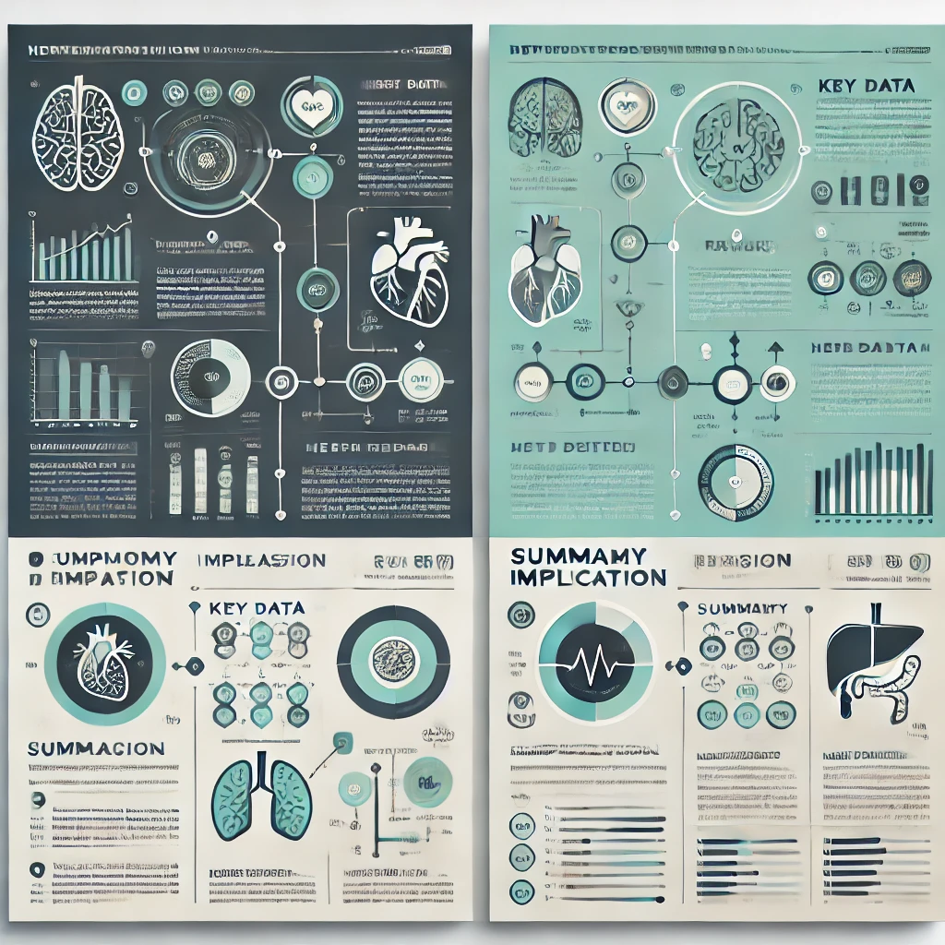

- INTRODUCTION
  - Overview of the topic
    - What is the topic?
Lorem ipsum dolor sit amet, consectetur adipiscing elit. Nullam sed felis at lorem volutpat dignissim. Vivamus vehicula, nunc sit amet laoreet tincidunt, turpis nulla tincidunt metus, nec pellentesque urna libero id mauris. Fusce non urna eu eros gravida dictum. Mauris fermentum est in libero malesuada, sed gravida purus ultricies. Nam ac interdum nisi. Sed at convallis magna.
    - What is the problem to solve?
Lorem ipsum dolor sit amet, consectetur adipiscing elit. Nullam sed felis at lorem volutpat dignissim. Vivamus vehicula, nunc sit amet laoreet tincidunt, turpis nulla tincidunt metus, nec pellentesque urna libero id mauris. Fusce non urna eu eros gravida dictum. Mauris fermentum est in libero malesuada, sed gravida purus ultricies. Nam ac interdum nisi. Sed at convallis magna.
    - What is the importance of the topic?
Lorem ipsum dolor sit amet, consectetur adipiscing elit. Nullam sed felis at lorem volutpat dignissim. Vivamus vehicula, nunc sit amet laoreet tincidunt, turpis nulla tincidunt metus, nec pellentesque urna libero id mauris. Fusce non urna eu eros gravida dictum. Mauris fermentum est in libero malesuada, sed gravida purus ultricies. Nam ac interdum nisi. Sed at convallis magna.
    - What would be the impact of our research results?
Lorem ipsum dolor sit amet, consectetur adipiscing elit. Nullam sed felis at lorem volutpat dignissim. Vivamus vehicula, nunc sit amet laoreet tincidunt, turpis nulla tincidunt metus, nec pellentesque urna libero id mauris. Fusce non urna eu eros gravida dictum. Mauris fermentum est in libero malesuada, sed gravida purus ultricies. Nam ac interdum nisi. Sed at convallis magna.

  - Heading 1
Lorem ipsum dolor sit amet, consectetur adipiscing elit. Nullam sed felis at lorem volutpat dignissim. Vivamus vehicula, nunc sit amet laoreet tincidunt, turpis nulla tincidunt metus, nec pellentesque urna libero id mauris. Fusce non urna eu eros gravida dictum. Mauris fermentum est in libero malesuada, sed gravida purus ultricies. Nam ac interdum nisi. Sed at convallis magna. Curabitur pretium ligula vitae nunc facilisis, vel aliquet magna blandit. Aenean vulputate nisi ac felis tempor, a varius elit suscipit.
  - Heading 2 and etc.
Etiam eget eros nec elit dapibus sollicitudin vel eget orci. Integer non dolor id lacus suscipit feugiat. Ut accumsan vel orci a condimentum. Cras pellentesque ligula vel ligula interdum, non gravida justo iaculis. Donec vel turpis non justo volutpat viverra. Suspendisse potenti. Nam bibendum vestibulum leo, non ultricies magna consequat id.

- OBJECTIVES
  - Study I. – Study title
Lorem ipsum dolor sit amet, consectetur adipiscing elit. Nullam sed felis at lorem volutpat dignissim. Vivamus vehicula, nunc sit amet laoreet tincidunt, turpis nulla tincidunt metus, nec pellentesque urna libero id mauris. Fusce non urna eu eros gravida dictum. Mauris fermentum est in libero malesuada, sed gravida purus ultricies.
  - Study II. – Study title
Lorem ipsum dolor sit amet, consectetur adipiscing elit. Nullam sed felis at lorem volutpat dignissim. Vivamus vehicula, nunc sit amet laoreet tincidunt, turpis nulla tincidunt metus, nec pellentesque urna libero id mauris. Fusce non urna eu eros gravida dictum. Mauris fermentum est in libero malesuada, sed gravida purus ultricies.
  - Study III – or further studies – Study title
Lorem ipsum dolor sit amet, consectetur adipiscing elit. Nullam sed felis at lorem volutpat dignissim. Vivamus vehicula, nunc sit amet laoreet tincidunt, turpis nulla tincidunt metus, nec pellentesque urna libero id mauris. Fusce non urna eu eros gravida dictum. Mauris fermentum est in libero malesuada, sed gravida purus ultricies.

- METHODS
  - Study I.
    - Study design
    - Setting

    - Ethics and patient consent
    - Participants

    - Variables and data sources
    - Bias and evidence synthesis
    - Statistical methods

  - Study II.
    - Literature search and eligibility criteria
.
    - Study selection and data extraction
    - Quality assessment

    - Data synthesis and analysis

- RESULTS
  - Study I: Population-based registry analysis
PLEASE USE RELEVANT SUBHEADINGS

8.2 Study II: Meta-analysis
PLEASE USE RELEVANT SUBHEADINGS
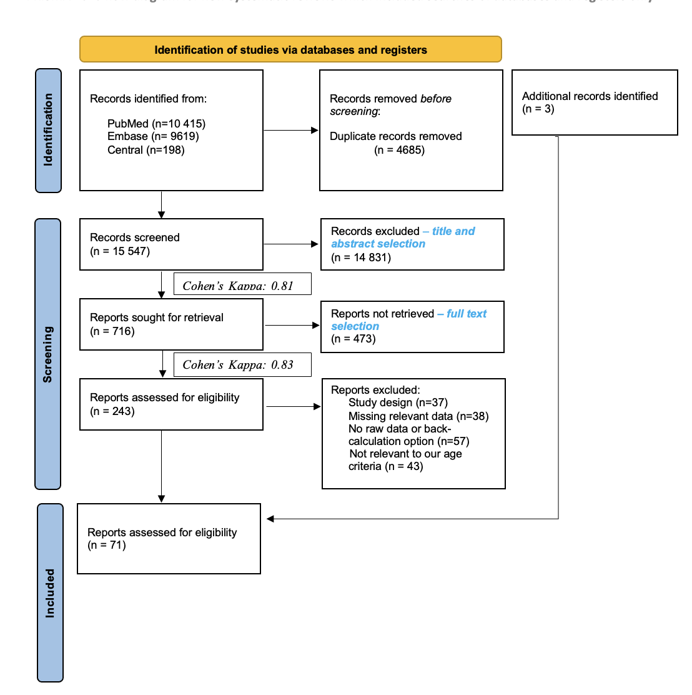

Figure XY. PRISMA 2020 flowchart representing the study selection process (reference)

Table XY. Basic characteristics of …
Congenital anomaly | ICD-10 Category | Age < 20 | N | Age 30-35 | N | Age 35-40 | N | Age > 35 | N | Age > 40 | N
All NCAs  (with or without CAs) | Q00-Q89 | 1.08 (0.89; 1.32) | 14 | 1.23 (0.85; 1.78) | 13 | 1.47 (0.87; 2.49) | 9 | 1.31 (1.06; 1.61) | 13 | 1.44 (1.25; 1.66) | 11
All NCAs  (without CAs) | Q00-Q89 | 1.21 (0.59; 2.49) | 5 | 1.54 (0.55; 4.32) | 6 | 1.73 (0.45; 6.70) | 5 | 1.37 (0.76; 2.45) | 6 | 1.25 (1.08; 1.46) | 6
All NCAs  (with CAs) | Q00-Q89 | 1.15 (0.87; 1.52) | 10 | 1.02 (0.99; 1.06) | 7 | 1.20 (0.99; 1.44) | 4 | 1.26 (1.12; 1.42) | 7 | 1.63 (1.26; 2.09) | 6
Nervous system | Q00-Q07 | 1.16 (0.74; 1.81) | 10 | 1.64 (0.70; 3.81) | 8 | 2.56 (0.64; 10.32) | 5 | 1.53 (0.80; 2.94) | 8 | 1.56 (0.67; 3.62) | 7
Encephalocele | Q01 | 1.76 (0.44; 7.12) | 3 | 1.51 (0.33; 6.83) | 3 | no data |  | 1.43 (0.57; 3.60) | 3 | no data
Congenital hydrocephalus | Q03 | 1.19 (1.02; 1.38) | 2 | no data |  | no data |  | no data |  | no data
Spina bifida | Q05 | 1.30 (0.93; 1.82) | 9 | 1.15 (0.65; 2.06) | 8 | 1.79 (0.61; 5.31) | 5 | 1.39 (0.75; 2.59) | 8 | 1.96 (0.72; 5.31) | 5
Anencephaly | Q00.0 | 1.40 (0.98; 1.99) | 9 | 1.15 (0.72; 1.84) | 8 | 1.20 (0.53; 2.72) | 6 | 1.02 (0.60; 1.72) | 8 | 1.30 (0.71; 2.38) | 6
Circulatory System | Q20-Q28 | 0.87 (0.68; 1.11) | 3 | 1.09 (1.00; 1.20) | 3 | 1.18 (0.94; 1.49) | 3 | 1.33 (0.97; 1.82) | 3 | 1.94 (1.28; 2.93) | 4
Congenital Heart Defects | Q20-Q26 | 0.87 (0.78; 0.97) | 10 | 1.45 (0.83; 2.52) | 10 | 1.91 (0.65; 5.62) | 6 | 1.50 (1.11; 2.04) | 10 | 1.75 (1.32; 2.32) | 6
Cleft lip and palate | Q35-Q37 | 0.93 (0.76; 1.14) | 6 | 1.58 (0.77; 3.22) | 6 | 1.85 (0.59; 5.75) | 4 | 1.47 (0.95; 2.28) | 6 | 1.57 (1.11; 2.20) | 4
Cleft palate | Q35 | 0.99 (0.56; 1.73) | 6 | 1.42 (0.66; 3.06) | 8 | 2.08 (0.54; 7.99) | 5 | 1.78 (1.16; 2.73) | 8 | 1.77 (1.48; 2.11) | 5
Digestive System | Q38-Q45 | 0.98 (0.71; 1.37) | 2 | no data |  | no data |  | no data |  | 2.16 (1.34; 3.49) | 2
Urinary System | Q60-Q64 | no data |  | 0.97 (0.75; 1.26) | 3 | no data |  | 0.86 (0.57; 1.29) | 3 | no data
Hypospadiasis | Q54 | 0.99 (0.91; 1.07) | 5 | 1.06 (0.96; 1.17) | 4 | no data |  | 1.11 (0.88; 1.39) | 4 | no data
Musculoskeletal System | Q65-Q79 | 0.88 (0.72; 1.08) | 2 | no data |  | 0.93 (0.71; 1.22) | 2 | 0.94 (0.65; 1.37) | 2 | 0.90 (0.55; 1.46) | 3
Congenital Diaphragmatic Hernia | Q79.0 | 0.96 (0.88; 1.06) | 5 | 1.74 (0.52; 5.80) | 4 | no data |  | 1.52 (0.79; 2.91) | 5 | no data
Omphalocele | Q79.2 | 1.44 (1.08; 1.92) | 14 | 1.13 (0.85; 1.50) | 14 | 1.35 (0.98; 1.87) | 13 | 1.47 (1.20; 1.79) | 14 | 2.57 (1.77; 3.73) | 13
Gastroschisis | Q79.3 | 3.08 (2.74; 3.47) | 22 | 0.32 (0.23; 0.44) | 17 | 0.27 (0.16; 0.47) | 12 | 0.22 (0.15; 0.32) | 17 | 0.41 (0.23; 0.74) | 11
Please state all abbreviations used in the table.
Lorem ipsum dolor sit amet, consectetur adipiscing elit. Nullam sed felis at lorem volutpat dignissim. Vivamus vehicula, nunc sit amet laoreet tincidunt, turpis nulla tincidunt metus, nec pellentesque urna libero id mauris.

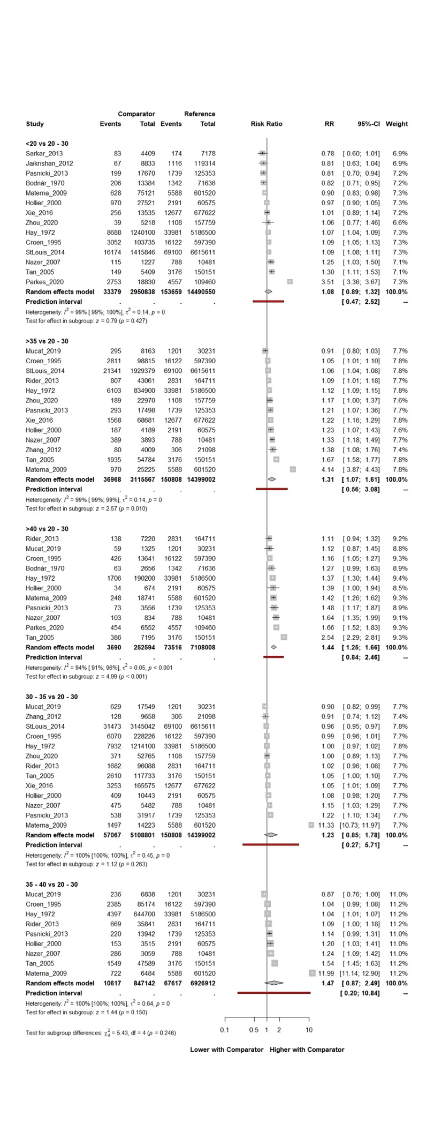
Figure 6. Forest plot representing the RR with 95% CI of all non-chromosomal anomalies (ICD-10: Q00-Q89) in different age groups compared to the 20-30 age groups

- DISCUSSION
  - Summary of findings, international comparisons (including all studies)

  - Strengths (including all studies)

  - Limitations (including all studies)

- CONCLUSIONS

- IMPLEMENTATIONS FOR PRACTICE

- IMPLEMENTATION FOR RESEARCH
Methodology issues

Study design

New aspects

- IMPLEMENTATION FOR POLICYMAKERS

- FUTURE PERSPECTIVES

- REFERENCES

- BIBLIOGRAPHY
  - Publications related to the thesis

  - Publications not related to the thesis

- ACKNOWLEDGEMENTS

