SUMMARY OF THE DISSERTATION STRUCTURE
Cover page
The cover page includes everyone's highest degree.
It should include the complex exam committee members.
Also add the official reviewers once the committee members for the final defense are decided.
Quote
Should indicate from whom it is quoted.
Table of contents
All numbered main/sub-chapters are included in the table of contents. All main chapters start on a new page.
Graphical abstract
It should incorporate all of your studies in one single graphical abstract.
Main structure
1.5 Line Spacing, justified text. The margins are 3 cm throughout the whole document. Maximum length between 30-60 pages without Cover Page, Table of Contents, List of Abbreviations, Student Profile, References, Bibliography, and Acknowledgements
Font – included in styles
Times New Roman font, size 12 throughout the paper.
Tables and numbering
Table title should be positioned above the table, while table legend should be below the table. The title should be self explanatory, keep the table structure simple, without merged cells if possible. Table numbering is continuous throughout the document. Please see example below.
Figures and numbering
Figure titles and descriptions should be positioned below the figure. The figure title should not only include simple statements like “Summary figure” or “Forest plot of xy outcome”, but it should also include a short description on the interpretation of the figure, e.g., “Forest plot representing the xy outcome compared between xy groups. The pooled results represent hazard ratios (HRs) with 95% confidence intervals (CIs). Subgroup analysis based on xy can be found…”. Figure numbering is continuous throughout the document. Please see example below.
References
APA 7th edition Vancouver.
Page numbering
Page numbering is centered at the bottom. Cover page should not be numbered.
Page layout – orientation – portrait or landscape
Use section breaks for changing the orientation of the pages. Don’t forget to check the page numbering in this case.
Publications – PDF attachment
Publications related to the thesis should be sent in PDF format in a separate document at the time of submission of the thesis.

phd thesis title
Ph.D. Thesis
Name with degree (e.g. M.D., D.M.D.)

Translational Medicine Program
XYZ Division

SEMMELWEIS UNIVERSITY

Supervisor: NAME with DEGREE (e.g. M.D., Ph.D.)
Official reviewers: NAME with DEGREE (e.g. M.D., Ph.D.)
NAME with DEGREE (e.g. M.D., Ph.D.)

Head of the Complex Examination Committee: NAME with DEGREE (e.g. M.D., Ph.D.)
Members of the Complex Examination Committee: NAME with DEGREE (e.g. M.D., Ph.D.)
NAME with DEGREE (e.g. M.D., Ph.D.)
NAME with DEGREE (e.g. M.D., Ph.D.)

Budapest
2026
“Please Write Here Quote”
Author

TABLE OF CONTENTS
1. LIST OF ABBREVIATIONS 5
2. STUDENT PROFILE 6
2.1. Vision and mission statement, specific goals 6
2.2. Scientometrics 6
2.3. Future plans 6
3. SUMMARY OF THE THESIS 7
4. GRAPHICAL ABSTRACT 8
5. INTRODUCTION 9
5.1. Overview of the topic 9
5.1.1. What is the topic? 9
5.1.2. What is the problem to solve? 9
5.1.3. What is the importance of the topic? 9
5.1.4. What would be the impact of our research results? 9
5.2. Heading 2 9
5.3. Heading 3 and etc. 10
6. OBJECTIVES 11
6.1. Study I. – Study Title 11
6.2. Study II. – Study Title 11
6.3. Study III. – Study Title 11
7. METHODS 12
7.1. Study I. 12
7.1.1. Methodology and Protocol 12
7.1.2. Eligibility Criteria 12
7.1.3. Information Sources and Search Strategy 12
7.1.4. Study Selection and Data Extraction 12
7.1.5. Risk of Bias and Quality of Evidence Assessment 12
7.1.6. Data Synthesis and Analysis 12
7.2. Study II. 12
7.2.1. Study Design 12
7.2.2. Study Setting 12
7.2.3. Ethics and Patient Consent 12
7.2.4. Participants 12
7.2.5. Variables and Data Sources 12
7.2.6. Bias, Confounding and Evidence Synthesis 12
7.2.7. Statistical Methods 12
8. RESULTS 13
8.1. Study I: Study Title - Meta-Analysis 13
8.1.1. Study Search and Selection 13
8.1.2. Primary Outcomes 16
8.1.3. Secondary Outcomes 17
8.1.4. Risk of Bias Assessment 17
8.1.5. Quality of Evidence 17
8.2. Study II: Study Title - Population-based Registry Analysis 17
8.2.1. Study Population 17
8.2.2. Primary Outcomes 17
8.2.3. Secondary Outcomes 17
8.2.4. Subgroup and Sensitivity Analyses 17
8.2.5. Additional Findings or Exploratory Analyses 17
9. DISCUSSION 18
9.1. Summary of Findings, International Comparisons (including all studies) 18
9.2. Strengths (including all studies) 18
9.3. Limitations (including all studies) 18
10. CONCLUSIONS 19
11. IMPLICATIONS FOR PRACTICE 20
12. IMPLICATIONS FOR RESEARCH 21
12.1. Methodology and Study Design 21
12.2. New Areas 21
13. IMPLICATIONS FOR POLICY MAKERS 22
14. FUTURE PERSPECTIVES 23
15. REFERENCES 24
16. BIBLIOGRAPHY 25
16.1. Publications Related to the Thesis 25
16.2. Publications not Related to the Thesis 25
17. ACKNOWLEDGEMENTS 26

LIST OF ABBREVIATIONS

BLANK Blandit Lorem Ante Nec Kata
LAPSE Lectus Auctor Pharetra Sed Elit
NOISE Nullam Ornare Ipsum Sed Elit
PURE Purus Ultricies Risus Efficitur
VAGUE Vivamus Auctor Gravida Ultricies Et

STUDENT PROFILE


Vision and mission statement, specific goals
Vivamus auctor, lectus vel consectetur gravida, purus sapien feugiat urna, et ultricies felis sapien ac metus. Phasellus dictum, nisl vel tempor hendrerit, augue ligula volutpat mi, at vehicula justo lorem nec orci. Pellentesque non libero lacus. Integer volutpat congue sem, in tempor lectus congue sit amet. Cras dictum nulla ut ante varius, sed fermentum erat consequat.

Scientometrics
Number of all publications: x
Cumulative IF: x.xxx
Av IF/publication: x.xxx
Ranking (SCImago): D1:, Q1:, Q2:, Q3:, Q4:
Number of publications related to the subject of the thesis: x
Cumulative IF: x.xxx
Av IF/publication: x.xxx
Ranking (Sci Mago): D1:, Q1:, Q2:, Q3:, Q4:
Number of citations on Google Scholar: x
Number of citations on MTMT (independent): x
H-index: x
The detailed bibliography of the student can be found on pages x-y.

Future plans
Vivamus auctor, lectus vel consectetur gravida, purus sapien feugiat urna, et ultricies felis sapien ac metus. Phasellus dictum, nisl vel tempor hendrerit, augue ligula volutpat mi, at vehicula justo lorem nec orci. Pellentesque non libero lacus. Integer volutpat congue sem, in tempor lectus congue sit amet. Cras dictum nulla ut ante varius, sed fermentum erat consequat.

SUMMARY OF THE THESIS
Maximum one page length.
Vivamus auctor, lectus vel consectetur gravida, purus sapien feugiat urna, et ultricies felis sapien ac metus. Phasellus dictum, nisl vel tempor hendrerit, augue ligula volutpat mi, at vehicula justo lorem nec orci. Pellentesque non libero lacus. Integer volutpat congue sem, in tempor lectus congue sit amet. Cras dictum nulla ut ante varius, sed fermentum erat consequat.
Nullam placerat nisi vitae velit luctus, a interdum nisi finibus. Aenean blandit ligula eget libero vehicula, ac iaculis risus tincidunt. Suspendisse potenti. Sed in facilisis tortor. Fusce at elit eget justo volutpat sodales non sit amet urna. Nam et nisl a neque ultricies tincidunt. Proin ornare lorem id magna pharetra, eget viverra nunc facilisis.

GRAPHICAL ABSTRACT
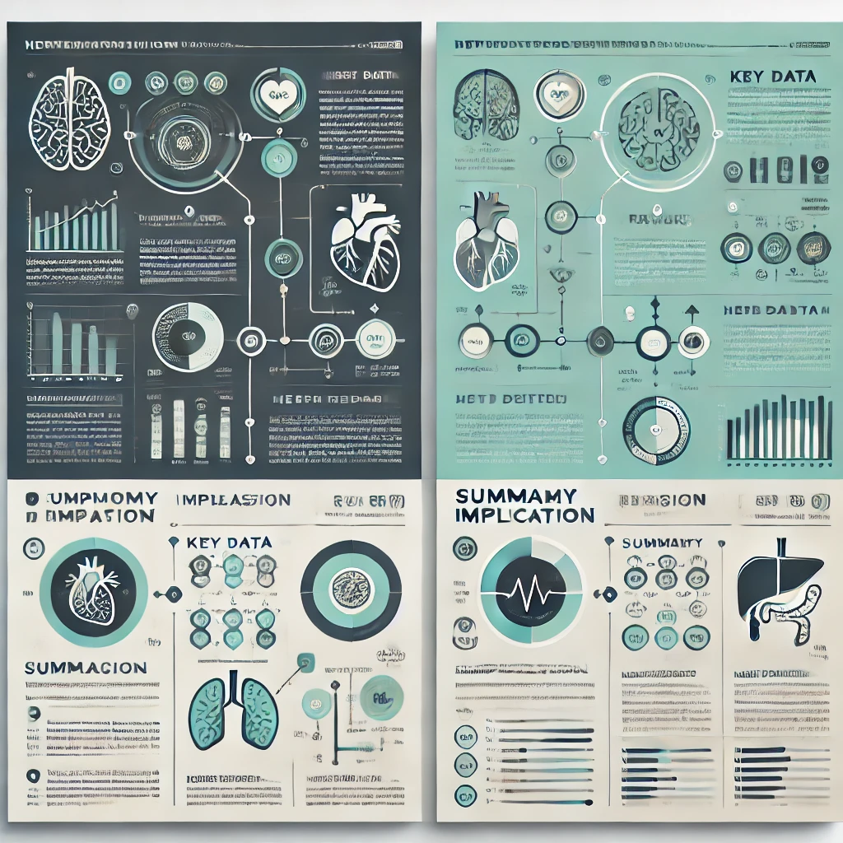
(including all studies)

INTRODUCTION

Overview of the topic

What is the topic?
Lorem ipsum dolor sit amet, consectetur adipiscing elit. Nullam sed felis at lorem volutpat dignissim. Vivamus vehicula, nunc sit amet laoreet tincidunt, turpis nulla tincidunt metus, nec pellentesque urna libero id mauris. Fusce non urna eu eros gravida dictum. Mauris fermentum est in libero malesuada, sed gravida purus ultricies. Nam ac interdum nisi. Sed at convallis magna.

What is the problem to solve?
Lorem ipsum dolor sit amet, consectetur adipiscing elit. Nullam sed felis at lorem volutpat dignissim. Vivamus vehicula, nunc sit amet laoreet tincidunt, turpis nulla tincidunt metus, nec pellentesque urna libero id mauris. Fusce non urna eu eros gravida dictum. Mauris fermentum est in libero malesuada, sed gravida purus ultricies. Nam ac interdum nisi. Sed at convallis magna.

What is the importance of the topic?
Lorem ipsum dolor sit amet, consectetur adipiscing elit. Nullam sed felis at lorem volutpat dignissim. Vivamus vehicula, nunc sit amet laoreet tincidunt, turpis nulla tincidunt metus, nec pellentesque urna libero id mauris. Fusce non urna eu eros gravida dictum. Mauris fermentum est in libero malesuada, sed gravida purus ultricies. Nam ac interdum nisi. Sed at convallis magna.

What would be the impact of our research results?
Lorem ipsum dolor sit amet, consectetur adipiscing elit. Nullam sed felis at lorem volutpat dignissim. Vivamus vehicula, nunc sit amet laoreet tincidunt, turpis nulla tincidunt metus, nec pellentesque urna libero id mauris. Fusce non urna eu eros gravida dictum. Mauris fermentum est in libero malesuada, sed gravida purus ultricies. Nam ac interdum nisi. Sed at convallis magna.

Heading 2
Lorem ipsum dolor sit amet, consectetur adipiscing elit. Nullam sed felis at lorem volutpat dignissim. Vivamus vehicula, nunc sit amet laoreet tincidunt, turpis nulla tincidunt metus, nec pellentesque urna libero id mauris. Fusce non urna eu eros gravida dictum. Mauris fermentum est in libero malesuada, sed gravida purus ultricies. Nam ac interdum nisi. Sed at convallis magna.

Heading 3 and etc.
Lorem ipsum dolor sit amet, consectetur adipiscing elit. Nullam sed felis at lorem volutpat dignissim. Vivamus vehicula, nunc sit amet laoreet tincidunt, turpis nulla tincidunt metus, nec pellentesque urna libero id mauris. Fusce non urna eu eros gravida dictum. Mauris fermentum est in libero malesuada, sed gravida purus ultricies. Nam ac interdum nisi. Sed at convallis magna.

OBJECTIVES

Study I. – Study Title
Lorem ipsum dolor sit amet, consectetur adipiscing elit. Nullam sed felis at lorem volutpat dignissim. Vivamus vehicula, nunc sit amet laoreet tincidunt, turpis nulla tincidunt metus, nec pellentesque urna libero id mauris. Fusce non urna eu eros gravida dictum. Mauris fermentum est in libero malesuada, sed gravida purus ultricies. Nam ac interdum nisi. Sed at convallis magna.

Study II. – Study Title
Lorem ipsum dolor sit amet, consectetur adipiscing elit. Nullam sed felis at lorem volutpat dignissim. Vivamus vehicula, nunc sit amet laoreet tincidunt, turpis nulla tincidunt metus, nec pellentesque urna libero id mauris. Fusce non urna eu eros gravida dictum. Mauris fermentum est in libero malesuada, sed gravida purus ultricies. Nam ac interdum nisi. Sed at convallis magna.

Study III. – Study Title
Lorem ipsum dolor sit amet, consectetur adipiscing elit. Nullam sed felis at lorem volutpat dignissim. Vivamus vehicula, nunc sit amet laoreet tincidunt, turpis nulla tincidunt metus, nec pellentesque urna libero id mauris. Fusce non urna eu eros gravida dictum. Mauris fermentum est in libero malesuada, sed gravida purus ultricies. Nam ac interdum nisi. Sed at convallis magna.

METHODS

Study I.

Methodology and Protocol

Eligibility Criteria

Information Sources and Search Strategy

Study Selection and Data Extraction

Risk of Bias and Quality of Evidence Assessment

Data Synthesis and Analysis

Study II.

Study Design

Study Setting

Ethics and Patient Consent

Participants

Variables and Data Sources

Bias, Confounding and Evidence Synthesis

Statistical Methods

RESULTS

Study I: Study Title - Meta-Analysis

Study Search and Selection
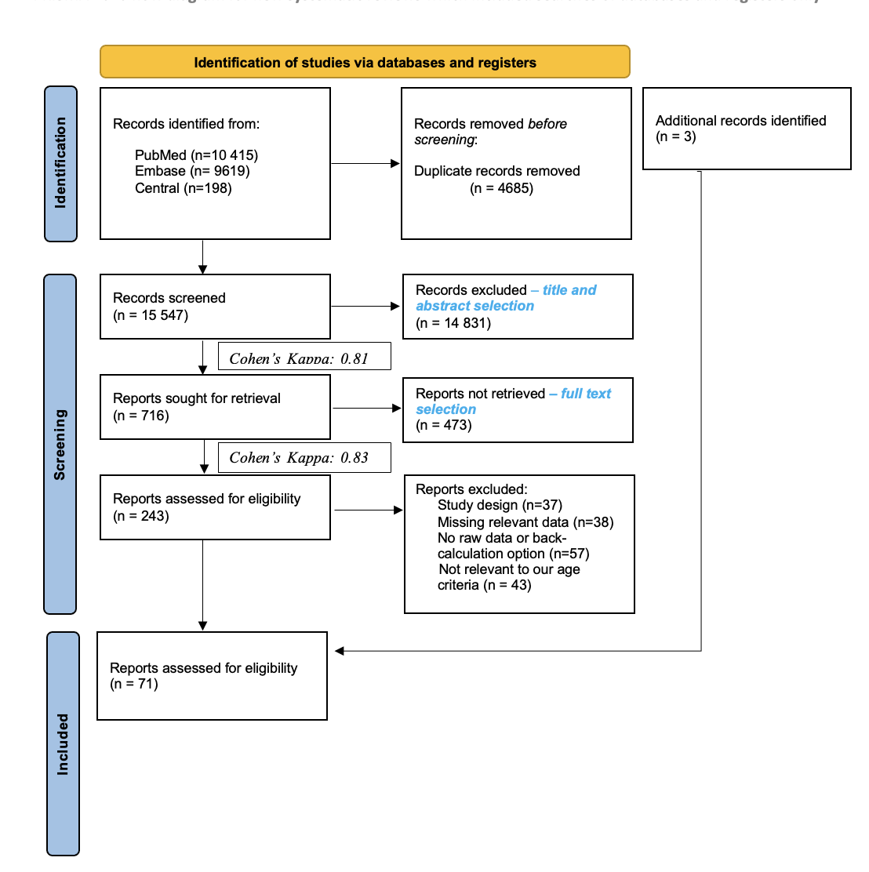

Figure XY. PRISMA 2020 flowchart representing the study selection process (reference).

Table XY. Basic characteristics of …
Congenital anomaly | ICD-10 Category | Age < 20 | N | Age 30-35 | N | Age 35-40 | N | Age > 35 | N | Age > 40 | N
All NCAs  (with or without CAs) | Q00-Q89 | 1.08 (0.89; 1.32) | 14 | 1.23 (0.85; 1.78) | 13 | 1.47 (0.87; 2.49) | 9 | 1.31 (1.06; 1.61) | 13 | 1.44 (1.25; 1.66) | 11
All NCAs  (without CAs) | Q00-Q89 | 1.21 (0.59; 2.49) | 5 | 1.54 (0.55; 4.32) | 6 | 1.73 (0.45; 6.70) | 5 | 1.37 (0.76; 2.45) | 6 | 1.25 (1.08; 1.46) | 6
All NCAs  (with CAs) | Q00-Q89 | 1.15 (0.87; 1.52) | 10 | 1.02 (0.99; 1.06) | 7 | 1.20 (0.99; 1.44) | 4 | 1.26 (1.12; 1.42) | 7 | 1.63 (1.26; 2.09) | 6
Nervous system | Q00-Q07 | 1.16 (0.74; 1.81) | 10 | 1.64 (0.70; 3.81) | 8 | 2.56 (0.64; 10.32) | 5 | 1.53 (0.80; 2.94) | 8 | 1.56 (0.67; 3.62) | 7
Encephalocele | Q01 | 1.76 (0.44; 7.12) | 3 | 1.51 (0.33; 6.83) | 3 | no data |  | 1.43 (0.57; 3.60) | 3 | no data
Congenital hydrocephalus | Q03 | 1.19 (1.02; 1.38) | 2 | no data |  | no data |  | no data |  | no data
Spina bifida | Q05 | 1.30 (0.93; 1.82) | 9 | 1.15 (0.65; 2.06) | 8 | 1.79 (0.61; 5.31) | 5 | 1.39 (0.75; 2.59) | 8 | 1.96 (0.72; 5.31) | 5
Anencephaly | Q00.0 | 1.40 (0.98; 1.99) | 9 | 1.15 (0.72; 1.84) | 8 | 1.20 (0.53; 2.72) | 6 | 1.02 (0.60; 1.72) | 8 | 1.30 (0.71; 2.38) | 6
Circulatory System | Q20-Q28 | 0.87 (0.68; 1.11) | 3 | 1.09 (1.00; 1.20) | 3 | 1.18 (0.94; 1.49) | 3 | 1.33 (0.97; 1.82) | 3 | 1.94 (1.28; 2.93) | 4
Congenital Heart Defects | Q20-Q26 | 0.87 (0.78; 0.97) | 10 | 1.45 (0.83; 2.52) | 10 | 1.91 (0.65; 5.62) | 6 | 1.50 (1.11; 2.04) | 10 | 1.75 (1.32; 2.32) | 6

Cleft lip and palate | Q35-Q37 | 0.93 (0.76; 1.14) | 6 | 1.58 (0.77; 3.22) | 6 | 1.85 (0.59; 5.75) | 4 | 1.47 (0.95; 2.28) | 6 | 1.57 (1.11; 2.20) | 4
Cleft palate | Q35 | 0.99 (0.56; 1.73) | 6 | 1.42 (0.66; 3.06) | 8 | 2.08 (0.54; 7.99) | 5 | 1.78 (1.16; 2.73) | 8 | 1.77 (1.48; 2.11) | 5
Digestive System | Q38-Q45 | 0.98 (0.71; 1.37) | 2 | no data |  | no data |  | no data |  | 2.16 (1.34; 3.49) | 2
Urinary System | Q60-Q64 | no data |  | 0.97 (0.75; 1.26) | 3 | no data |  | 0.86 (0.57; 1.29) | 3 | no data
Hypospadiasis | Q54 | 0.99 (0.91; 1.07) | 5 | 1.06 (0.96; 1.17) | 4 | no data |  | 1.11 (0.88; 1.39) | 4 | no data
Musculoskeletal System | Q65-Q79 | 0.88 (0.72; 1.08) | 2 | no data |  | 0.93 (0.71; 1.22) | 2 | 0.94 (0.65; 1.37) | 2 | 0.90 (0.55; 1.46) | 3
Congenital Diaphragmatic Hernia | Q79.0 | 0.96 (0.88; 1.06) | 5 | 1.74 (0.52; 5.80) | 4 | no data |  | 1.52 (0.79; 2.91) | 5 | no data
Omphalocele | Q79.2 | 1.44 (1.08; 1.92) | 14 | 1.13 (0.85; 1.50) | 14 | 1.35 (0.98; 1.87) | 13 | 1.47 (1.20; 1.79) | 14 | 2.57 (1.77; 3.73) | 13
Gastroschisis | Q79.3 | 3.08 (2.74; 3.47) | 22 | 0.32 (0.23; 0.44) | 17 | 0.27 (0.16; 0.47) | 12 | 0.22 (0.15; 0.32) | 17 | 0.41 (0.23; 0.74) | 11
Please state all abbreviations used in the table.
Lorem ipsum dolor sit amet, consectetur adipiscing elit. Nullam sed felis at lorem volutpat dignissim. Vivamus vehicula, nunc sit amet laoreet tincidunt, turpis nulla tincidunt metus, nec pellentesque urna libero id mauris.

Primary Outcomes
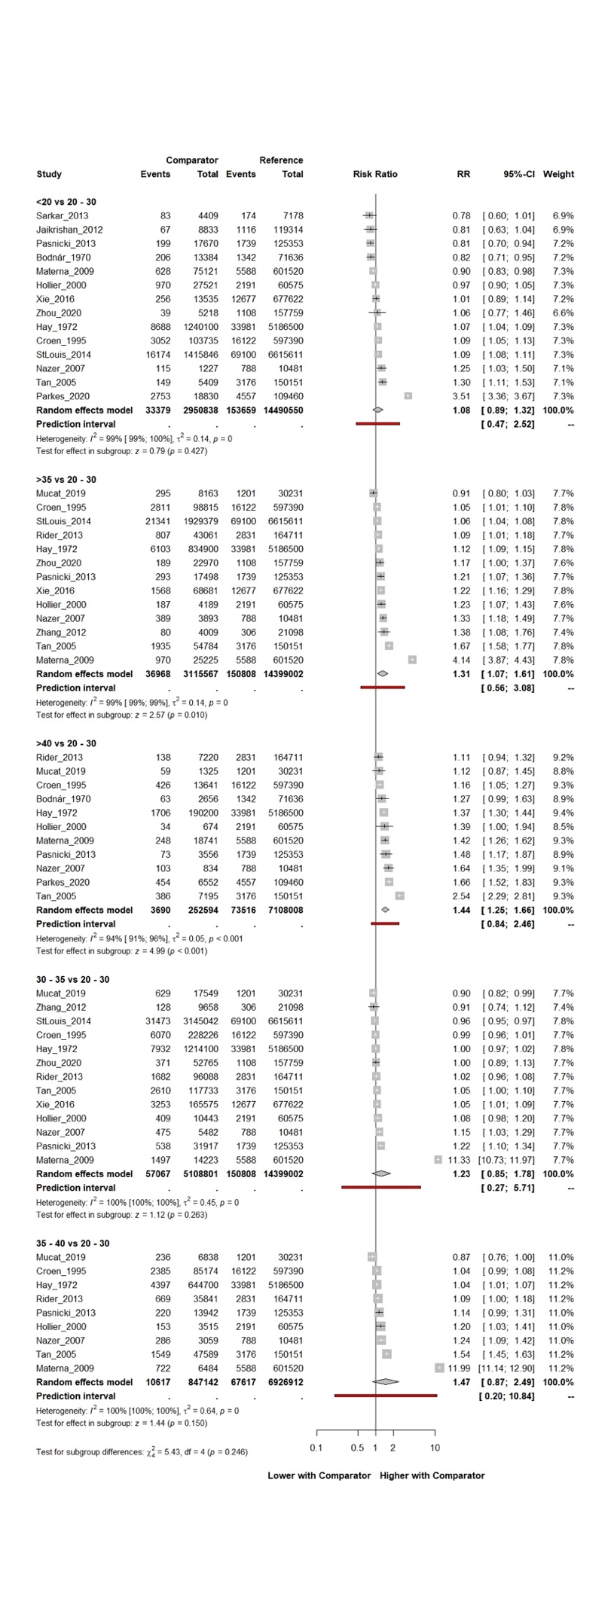
Figure x. Forest plot representing the RR with 95% CI of all non-chromosomal anomalies (ICD-10: Q00-Q89) in different age groups compared to the 20-30 age groups (reference).

Secondary Outcomes

Risk of Bias Assessment

Quality of Evidence

Study II: Study Title - Population-based Registry Analysis

Study Population

Primary Outcomes

Secondary Outcomes

Subgroup and Sensitivity Analyses

Additional Findings or Exploratory Analyses

DISCUSSION

Summary of Findings, International Comparisons (including all studies)

Strengths (including all studies)

Limitations (including all studies)

CONCLUSIONS

IMPLICATIONS FOR PRACTICE

IMPLICATIONS FOR RESEARCH

Methodology and Study Design

New Areas

IMPLICATIONS FOR POLICY MAKERS

FUTURE PERSPECTIVES

REFERENCES

BIBLIOGRAPHY

Publications Related to the Thesis

Publications not Related to the Thesis

ACKNOWLEDGEMENTS

